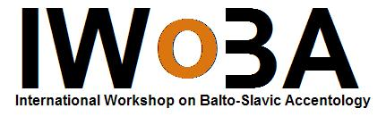
Call for Papers - Third International Workshop on Balto-Slavic Accentology

Title: IWoBA III
Date: 27-29 July 2007
Location: Leiden University, The Netherlands
Website: http://www.accentology.leidenuniv.nl
Contact: t.c.pronk@let.leidenuniv.nl
Call deadline: 15 March 2007

Submissions are invited for papers that discuss issues in comparative and historical Balto-Slavic accentology, including the prehistory and history of separate Baltic and Slavic languages, as well as synchronic and dialectal issues that have to do with accentology. Talks will last 20 minutes, followed by 10 minutes of discussion.

Those wishing to offer a paper are kindly requested to submit the registration form electronically to t.c.pronk@let.leidenuniv.nl, to arrive no later than 15 March 2007. The registration form can also be filled out on http://www.accentology.leidenuniv.nl (forthc.). Notification will follow at the end of March 2007.

A small registration fee, to include refreshments during the workshop and a book of abstracts, will be charged.

Directly following the Workshop the Leiden Summer Schools in Indo-European and in Russian will be held from 30 July till 10 August. For more information visit the website http://www.letteren.leidenuniv.nl/summerschools.

Contact
Organizer: Tijmen Pronk
Email: t.c.pronk@let.leidenuniv.nl
Tel.: +31-71-5272203

Third International Workshop on
Balto-Slavic Accentology
27–29 July 2007
Leiden University
http://www.accentology.leidenuniv.nl
Registration Form

Name

Affiliation

Address

E-mail address

Working title of presentation
(if no presentation is given,
please leave blank)

Please fill out this form and return it to
t.c.pronk@let.leidenuniv.nl no later than 15 March 2007.

